Return Menu

By selecting “RETURN” from the “Main Menu”, the user will be presented the form shown below.

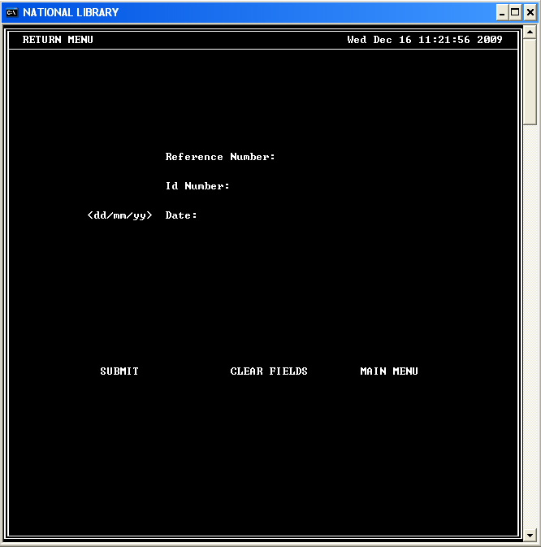

Upon filling the form with valid information:

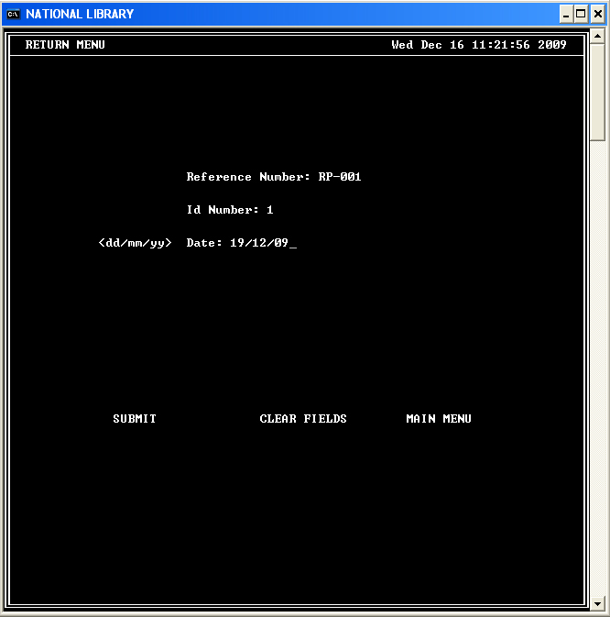

The user will be prompted to confirm their action or to cancel.

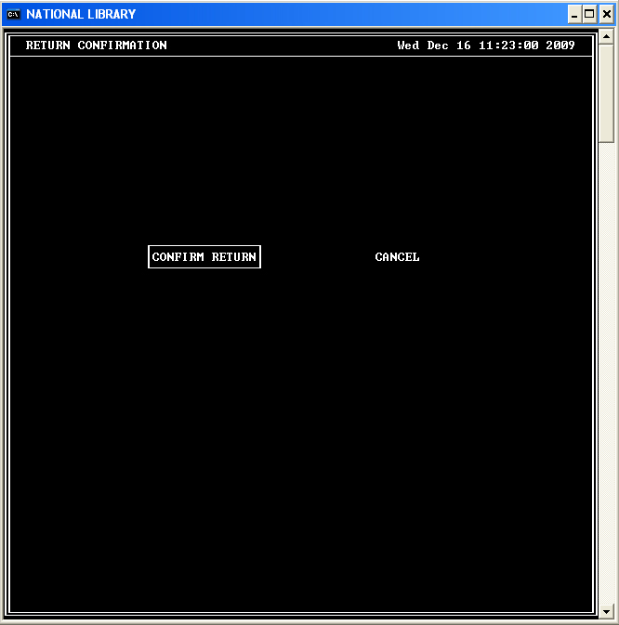

If the user chooses to return the loaned material, the information will be updated and the user will be shown the following screen.

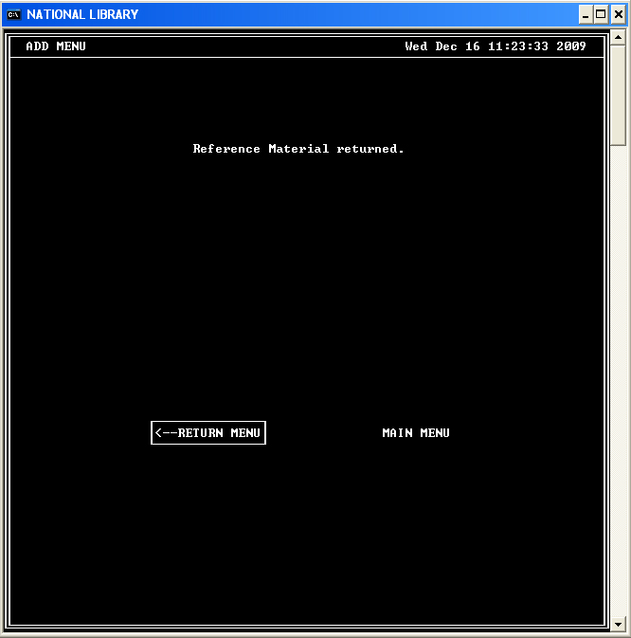

The user can then go to the “Return Menu” to return another loaned material or to go to the “Main Menu”.

